HCIN6222POE Part 1

ST10341842

Mvinjelwa Buhlebenkosi

2024

Contents

Contents 1

Part 1: Research Report on Fitness App for students 2

Functionality of the FITBUDDY 2

1.1.1 Functionality of FITBUDDY 2

1.2 Implementation Plan 4

1.2.1 Usability Goals 4

1.2.2 Desirable Aspects of User Experience 4

1.2.3 Design Principles 5

1.2.4 Interaction Types 6

1.2.5 Social Interactions 6

1.2.6 Emotional Interaction 7

1.2.7 Web Content Accessibility Guidelines (WCAG) 2.0 8

Part 2 9

References 17

## 

## Part 1: Research Report on Fitness App for students

## 

### Functionality of the FITBUDDY

### 1.1.1 Functionality of FITBUDDY

* **Gym Specials:** South African students, particularly in major cities like Cape Town, Johannesburg, and Durban, often face financial constraints. Many gyms offer student discounts, but these are not always easily accessible or advertised. The fitness app could partner with gym companies and fitness centers such as Virgin Active and Planet Fitness, which already offer student membership deals. In addition, local gyms in university areas like Campus Fitness at the University of Cape Town could be featured, helping students save money while staying fit.
* **Healthy Food Options:** Given the rising cost of living and the consumption of fast food, it's essential to provide students with healthy, affordable meal options. The app could highlight affordable healthy meal providers such as Kauai, which offers nutritious meals at student-friendly prices, or smaller local vendors that focus on healthy food. The app could also integrate with services like Mr D Food or Uber Eats, showcasing healthy meal options from nearby restaurants with student discounts. It will partner with nationwide chains of Super markets like Woolworths, Superspar, Pick n Pay and Shoprite advertising specials they have based on your preferred diet choices.
* **Fitness Events:** South Africa has a vibrant fitness culture, particularly in outdoor activities like hiking, running, and cycling. The app could promote events such as park runs, which are free 5-kilometer runs held weekly in cities across South Africa. Additionally, the app could feature local yoga sessions, cycling groups, and student-led fitness activities organized by universities like Stellenbosch University or the University of KwaZulu-Natal, making it easier for students to participate in community fitness events.
* **Support Groups:** Fitness support groups are vital for motivation, particularly in South Africa, where communal activities are culturally significant. The app could help students form virtual or physical support groups at universities, allowing them to share fitness tips and plan group workouts. For example, students at Wits University could form a running club where members log their runs, share progress, and motivate one another. Such initiatives reflect South Africa's strong sense of community, providing mutual support and encouragement.
* **Progress Tracking:** The app could feature workout and nutrition tracking tools tailored to students’ unique lifestyles. South African students often juggle tight schedules between classes, part-time jobs, and other commitments, so quick, easy-to-use progress trackers are essential. The app could also integrate with Discovery Vitality, which is popular in South Africa for rewarding fitness activities with points that can be redeemed for discounts on healthy food, travel, and fitness gear.
* **Personalized Recommendations:** Using geo-location data, the app could recommend fitness events, gyms, or healthy restaurants based on the student's location. For example, students at the University of Pretoria could receive notifications about local gyms or healthy eateries nearby. This feature would be very important in a country with different regions and income levels, making sure that students in both cities and rural areas get useful suggestions.
* **Student-Friendly Interface:** The app will cater specifically to students by offering features like simplified navigation, discounted fitness programs, and easy access to health resources.
* **Mobile Optimization:** Given that students often use mobile devices, the app must ensure that its functionality is optimized for mobile use. The design should allow quick access to essential features like tracking workouts or signing up for fitness events.
* **Offline Accessibility:** Features like workout logs or diet tracking should be accessible even without internet connectivity, helping students save on data costs, which is a significant issue in South Africa.

.

### 1.2 Implementation Plan

### 1.2.1 Usability Goals

**Usability Goals:** Usability goals ensure that an app or website is simple and efficient for users to navigate and achieve their objectives. They focus on making products easy to learn and enjoyable to use. An example of a usability goal could be making an app work efficiently on basic smartphones with minimal data usage (Usability.gov, n.d.).

* **Simple Navigation**: South African students come from different economic backgrounds, and many might be using basic smartphones with limited data. So, the app should be lightweight, use little data, and have easy-to-use navigation. Research by ICASA shows that many people in South Africa use mobile phones, but data costs are still a problem for many (ICASA, 2020). Features like offline workout tracking could help users who don't always have internet access.
* **Search Functionality:** A strong search tool would help students quickly find fitness events, meal deals, or gym discounts. This tool would work like the easy-to-use search feature on Takealot, which is popular with South Africans. For example, a student could easily search for "yoga classes in Johannesburg" or "healthy meals near Cape Town" using the app's search tool.
* **User Testing**: Conduct user testing within different student groups across various South African universities to gather insights on what works well and what needs improvement.
* Mobile Responsiveness: Ensure the app adapts seamlessly to various screen sizes and devices, providing an optimized user experience on smartphones, tablets, and desktop computers.
* Minimal Data Consumption: The app should be designed to function with minimal data usage by reducing high-resolution images or unnecessary features, benefiting students who face high data costs.

### 1.2.2 Desirable Aspects of User Experience

**Design Aspects of User Experience:**The desirable aspects of user experience refer to features or qualities that make using an app enjoyable and meaningful. These include engagement, ease of use, and feedback that resonates with the user's needs (Interaction Design Foundation, n.d.).

* **Engagement:** To get students involved, the app could include polls and challenges that relate to their culture. For example, challenges could be based on well-known South African events like the Comrades Marathon or fitness movements like Move One Million, which focus on community and health. By connecting challenges to these cultural events, the app would appeal more to South African students.
* **Feedback Mechanisms:** Quick feedback on workout progress or diet logs can help motivate students to stay consistent. In South Africa, where fitness levels differ greatly, the app could give personalized feedback based on each student's progress. For example, if a student hasn’t been active for a week, the app could send a motivational message or suggest a local event to help them get back on track.
* **Rewards System**: Introduce reward points for reaching fitness milestones, redeemable at local businesses or through app partners, enhancing student engagement
* Customizable User Interface: Allow students to personalize their dashboard, choosing which features and information appear first. This improves engagement as users feel the app is tailored to their needs.
* Gamification: Introduce gamification elements like fitness quests or achievements to keep users engaged. For example, completing weekly challenges could unlock new app features or rewards.

### 1.2.3 Design Principles

**Design Principles:** Design principles are a set of guidelines that ensure the consistency, clarity, and ease of use of an app. They help in designing intuitive and user-friendly products (Nielsen Norman Group, 2020).

* **Consistency**: The app should use design features that South African users are familiar with, like simple icons and clear labels in English, Zulu, or Afrikaans, to serve the country’s multilingual population. South African banking apps like FNB and Capitec are good examples of apps that stay consistent while being easy to use and accessible to people from different language and economic backgrounds.
* **Clarity**: Clearly labeled buttons and sections are essential to prevent confusion, especially for students who might be new to fitness apps. For instance, instead of using vague terms like "Progress" or "Nutrition," the app could use specific phrases like "Track My Workouts" or "Healthy Food Near Me." These clear labels would make the app easy to use, similar to the Discovery Vitality app, which is known for its user-friendly design.
* **Minimalist Design**: A clean and simple design that prioritizes essential functions will make it easier for students to use the app without being overwhelmed.
* Accessibility: Design the app according to accessibility guidelines such as WCAG to ensure that visually impaired students can still navigate the app through features like screen readers or voice commands.
* Feedback Consistency: Ensure all actions within the app provide immediate and understandable feedback. For example, after completing a workout log, a success message should appear, confirming the action.

### 1.2.4 Interaction Types

**Interaction Types:** Interaction types describe how users engage with a system or app. Examples include direct manipulation, such as tapping on a screen to interact with objects, or form filling to input information (Interaction Design Foundation, n.d.).

* **Direct Manipulation:** Users should be able to interact directly with features like gym deals or event listings. For example, a student in **Durban** could click directly on a local gym special to sign up for a membership or join a **free yoga class** by tapping on the event listing.
* **Form Filling**: Filling out forms to track workouts or join groups should be simple to handle data limitations. Using pre-filled forms or checkboxes can cut down on manual data entry, making it easier for students to log their activities quickly.
* **Instant Feedback**: Provide immediate feedback when users complete activities, such as logging a workout or finding a gym, to create a seamless experience.
* **Voice Commands:** Integrate voice command functionalities so users can log activities or search for fitness events without manual input. This can be beneficial for students who multitask or have disabilities.
* **Gesture-based Navigation**: For students using mobile devices, enable swipe or gesture-based navigation to make the app faster and more intuitive for users who prefer touch interactions.

### 1.2.5 Social Interactions

**Social Interaction:** Social interaction features in apps enable users to connect, share experiences, and engage with communities. For example, forums or group challenges that let users collaborate and support each other (Interaction Design Foundation, n.d.).

* **Discussion Forums**: The app could have fitness forums where students share experiences, ask questions, or find workout buddies. Since community is important in South African culture, these forums would help students connect with others from different regions, backgrounds, and universities. For example, a forum for University of Johannesburg students could let them share tips on the best gyms or outdoor workout spots in their area.
* **Group Challenges**: The app could feature national fitness challenges, like a “10,000 Steps Challenge,” with leaderboards showing students from different universities. The app might even team up with local brands like Adidas South Africa or Sportsmans Warehouse to offer prizes for winners, boosting participation and motivation.
* **Collaboration with Local Fitness Influencers**: Introduce features where South African fitness influencers can host challenges or provide fitness tips, boosting app visibility and engagement.
* **University-Specific Communities**: Create community pages for individual universities where students can connect with each other, share fitness tips, and plan group activities.
* Peer-to-Peer Challenges: Introduce a feature where students can challenge their friends or fellow students to fitness challenges directly through the app, enhancing engagement through friendly competition.

### 1.2.6 Emotional Interaction

**Emotional Interaction:** Emotional interaction involves creating experiences that resonate with users emotionally, such as motivating messages or rewards for achievements, making users feel connected and encouraged (Interaction Design Foundation, n.d.).

* **Celebrating Achievements**: In South African culture, where community recognition is important for motivation, the app could give badges for milestones like completing a workout streak or reaching a fitness goal. These digital badges could be shared on social media platforms like Facebook or Instagram, similar to how achievements are shared on apps like Strava.
* **Encouraging Messages:** The app could send personalized motivational messages in English, Afrikaans, or Zulu to reflect South Africa’s linguistic diversity. Messages like “Keep going, you're doing great!” in a user’s preferred language could make users feel more connected and motivated.
* **Local Motivational Content**: Feature motivational messages and success stories from South African students to encourage others. These messages should be personalized and delivered based on the user’s fitness progress.
* **Celebratory Animations**: Use animations or sound effects to celebrate when students reach a goal or milestone, making the experience more rewarding.
* **Localized Motivational Content:** Incorporate culturally relevant motivational quotes or health tips from local South African fitness experts, inspiring students by resonating with their background and community.

### 1.2.7 Web Content Accessibility Guidelines (WCAG) 2.0

**WCAG:**WCAG 2.0 sets out standards to make web content more accessible to people with disabilities. This includes providing text alternatives for images and ensuring keyboard navigation (Web Accessibility Initiative, n.d.).

* **Providing Text Alternatives:** The app should include descriptive alt text for all images to assist users with visual impairments, ensuring they can interact fully with the app. With a significant number of people with disabilities in South Africa, this aligns with national policies like the Promotion of Equality and Prevention of Unfair Discrimination Act (PEPUDA).
* **Keyboard Navigation:** The app should be fully functional using a keyboard for students with mobility impairments. This is especially important in educational settings like the University of Cape Town, where students have diverse needs.
* **Color Contrast:** High contrast between text and background is crucial for readability, especially for students using low-quality devices in bright outdoor settings, which is common in South Africa. Inspired by South African apps like SnapScan, which focus on clear design for mobile users, this feature would make the app accessible in various environments.
* **Mobile-Friendly Accessibility**: Ensure that accessibility features, such as screen readers and adjustable font sizes, are fully functional on mobile devices.
* Adjustable Text Size and Font: Include options for users to adjust the font size and style to suit their preferences or accessibility needs, ensuring readability for students with visual impairments or dyslexia. This feature will cater to diverse user preferences and ensure inclusivity across devices.

### Part 2

**FITBUDDY App Functionality Overview**

FITBUDDY is a comprehensive fitness app designed specifically for South African students, addressing their unique needs and challenges in maintaining an active lifestyle.

1. **Gym Specials**: The app partners with major gym chains like Virgin Active and Planet Fitness, as well as local gyms near universities, to provide students with easy access to discounted memberships and specials, making fitness more affordable.
2. **Healthy Food Options**: FITBUDDY highlights nutritious meal options from popular vendors like Kauai and integrates with food delivery services to showcase healthy meals at discounted prices from nearby restaurants and supermarkets.
3. **Fitness Events**: The app promotes local fitness events such as park runs, yoga sessions, and university-led activities, facilitating community engagement and encouraging students to participate in fitness initiatives.
4. **Support Groups**: FITBUDDY enables students to form virtual and physical fitness support groups, fostering motivation and accountability through shared fitness goals and activities.
5. **Progress Tracking**: Users can easily track their workouts and nutrition through intuitive tools tailored for busy student lifestyles, including integration with rewards programs like Discovery Vitality.
6. **Personalized Recommendations**: Utilizing geo-location data, the app provides tailored suggestions for nearby gyms, healthy eateries, and fitness events based on users’ current locations.
7. **Student-Friendly Interface**: Designed for easy navigation, the app features a simplified layout, making it accessible for students with varying tech skills.
8. **Mobile Optimization**: With a focus on mobile users, FITBUDDY ensures all functionalities are optimized for quick access, even with limited data.
9. **Offline Accessibility**: Key features, such as workout logs and diet tracking, remain functional offline, addressing data cost concerns prevalent among South African students.
10. **Engagement Features**: The app incorporates gamification elements, rewards systems, and culturally relevant challenges to enhance user engagement and motivate students.

Figure 1 WELCOME SCREEN

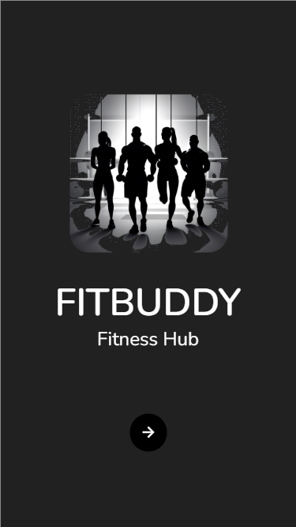

**Welcome Screen –**

The FITBUDDY app's Welcome Screen is designed to introduce users to the platform and its fitness-focused purpose.

**First Impressions:** The image of people running together promotes a sense of community and motivation, reflecting the app's goal of group workouts. The simple design with the FITBUDDY logo helps users quickly understand that the app is about fitness.

**User-Friendly Design:** The dark background with white text makes everything easy to read, and the clear button helps users easily move to the next step. This makes the app simple to use, especially for students.

**Engagement:** The image suggests a group fitness experience, encouraging users to join or create fitness groups, promoting social interaction from the start.

**Mobile Friendly:** The clean and modern design likely works well on different screen sizes, making it ideal for students using smartphones.

Figure 2 ONBOARDING

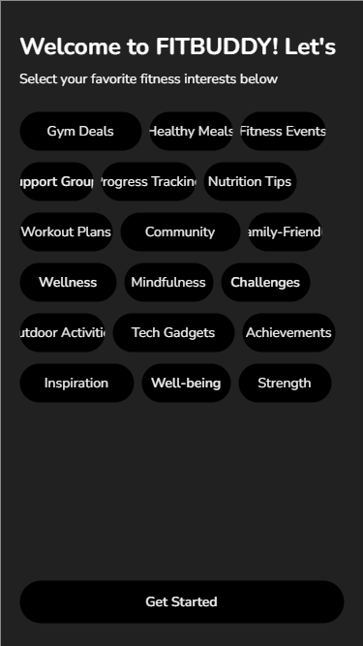

**Onboarding Screen** –

**Purpose:** The Onboarding Page lets users (students) pick their fitness interests, helping the app personalize content and recommendations based on their preferences.

**Personalization & Engagement:** By selecting interests, users receive content tailored to their preferences, increasing engagement and making the app more relevant to their fitness journey.

**User-Centred Design:** The onboarding process is flexible and inclusive, catering to different student profiles and needs.

**Connection to Other Pages:** The user's onboarding choices influence what appears on the Home and Profile pages, such as workout plans, meal promotions, and event notifications.

Figure 3 HOME SCREEN

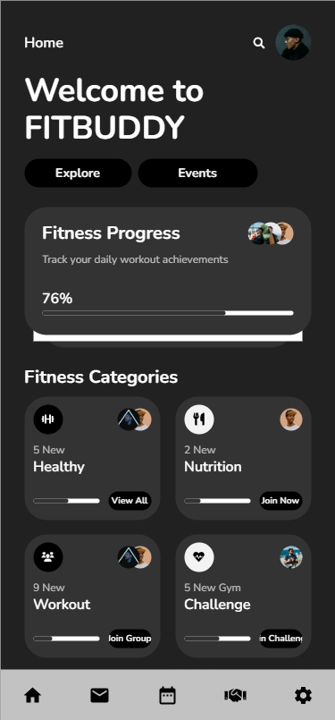

**Home Screen –**

**Welcome to FITBUDDY:** The heading greets users with options to explore or view events, helping them easily access fitness challenges and local activities right away.

**Fitness Progress:** Highlights the user's daily workout achievements, motivating them to stay on track with their fitness goals.

**Fitness Categories:** Offers options like Healthy, Nutrition, Workout, and Challenges, allowing users to easily explore and join different fitness activities.

**Bottom Navigation Icons**: Includes quick access to messages, events, challenges, and settings, making navigation fast and easy.

Figure 4 Home Screen 2

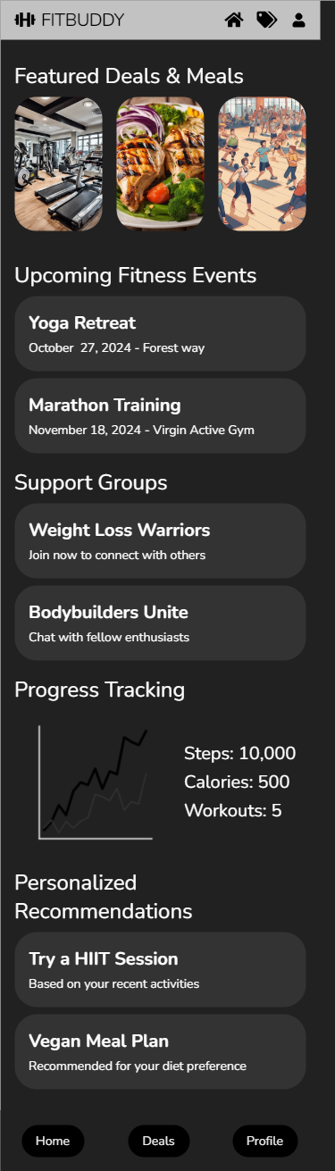

**Home screen 2** –

**Featured Deals & Meals:** Promotes special offers from local gyms and restaurants, supporting the goal of promoting fitness deals and healthy food.

**Upcoming Fitness Events:** Lists local events like yoga retreats and marathons, encouraging users to join and stay engaged.

**Support Groups:** Offers groups like “Weight Loss Warriors” for users to connect with others, promoting social interaction and motivation.

**Progress Tracking**: Shows the user’s fitness stats (steps, calories, workouts), helping them track their progress.

**Personalized Recommendations:** Suggests activities or meal plans based on user preferences, offering personalized advice.

**Bottom Navigation:** Provides easy access to Home, Deals, and Profile, making the app simple to use on mobile.

Figure 5 Deals & Events

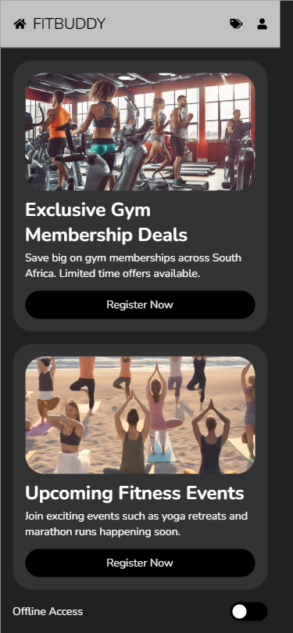

**Deals and Events screen** –

**Exclusive Gym Memberships:**

Allows users to register for discounted gym memberships across South Africa.

Simplifies the process of finding and signing up for local gym deals with a single click.

**Upcoming Fitness Events:**

Displays local fitness events (e.g., marathons, yoga classes) for easy registration.

Helps users track and stay committed to events they've signed up for.

**Offline Access and Notifications:**

Users can receive notifications about deals and events even without internet access.

The app preloads event info based on location, making it usable offline and ensuring users don’t miss important updates.

**User Experience and Design Flow:**

Simple layout makes it easy for users to find gym deals and events on one page, reducing the need to navigate between sections.

Clean design ensures users can focus on finding deals or events without getting overwhelmed.

**Personalization & Notifications:**

After onboarding, the page shows personalized gym deals and event suggestions based on user preferences.

Notifications keep users engaged, reminding them of upcoming events and deals, even when they’re not using the app.

Figure 6 Profile Screen

**Profile Screen** –

**Purpose:**

The Profile Screen serves as a centralized area where users can view and manage their fitness data, including workout history, goals, and preferences. It allows users to update their information, track their progress, and adjust their fitness objectives over time.

**Personalization & Engagement:**

By enabling users to input and adjust personal fitness data (e.g., preferred workout types, fitness goals, meal preferences), the profile screen personalizes the app experience. This not only increases user engagement but also ensures that recommendations (e.g., workout plans, meal suggestions) align with the user’s evolving needs.

**User-Centred Design:**

The profile screen is designed with simplicity and usability in mind. It supports easy data entry and editing, ensuring users can update their fitness journeys without unnecessary steps. The profile interface is clean and intuitive, reducing **cognitive load for users.**

**Connection to Other Pages:**

The data collected on this screen influences several other screens, such as personalized fitness deals and event recommendations. For example, users who focus on strength training may receive gym offers or event invitations related to weightlifting competitions.

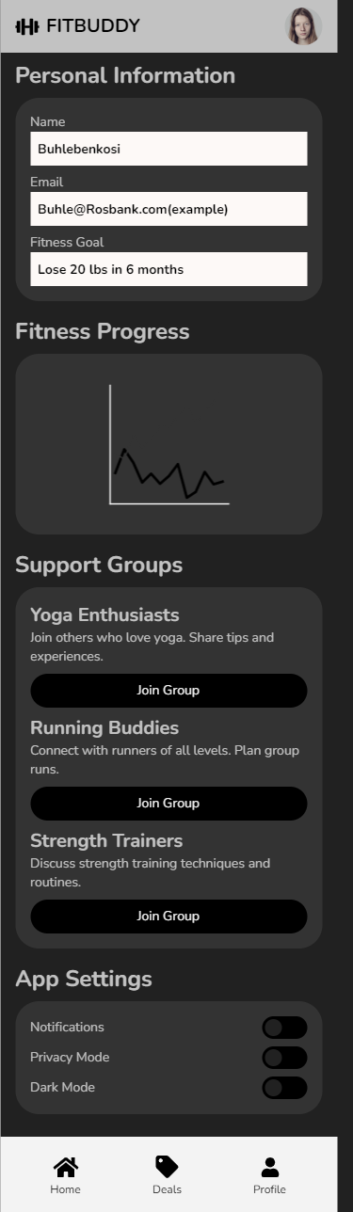

Figure 7 Discover Screen

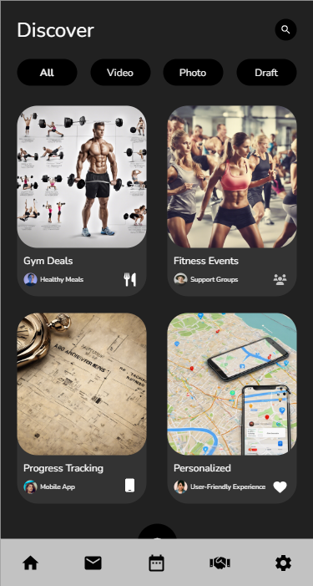

**Discover Screen** –

**Purpose:**

The Discover Screen shows personalized fitness events and deals based on location and preferences, making it easy for students to find relevant fitness options.

**Personalization & Engagement:**

Recommendations are tailored to each user, increasing engagement. The design is simple, with filters to help users find what they need quickly.

**Interaction & Usability:**

Users can easily click on events or deals to learn more, with instant feedback to confirm actions. The screen is well-organized and easy to use.

**Accessibility:**

The Discover Screen is designed with keyboard navigation and other accessibility features, ensuring it's usable for everyone.

Figure 8 Product Detail Screen

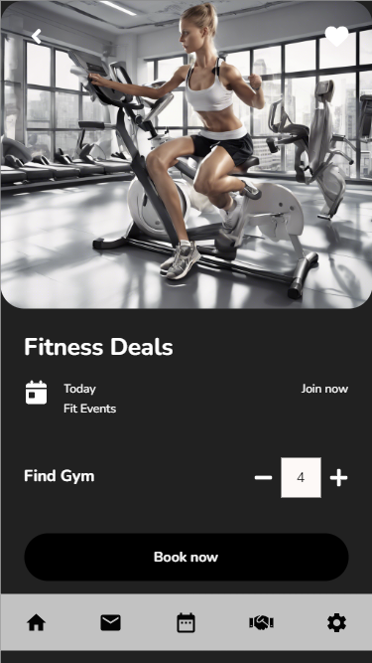

**Fitness Deals** –

**Purpose:**

This screen shows special offers on gym memberships and fitness gear, helping students find affordable fitness options.

**Personalization & Engagement:**

Deals are personalized based on user preferences and location, encouraging users to engage with offers that fit their needs.

**Interaction & Usability:**

The layout is clean and simple, making it easy for users to explore and sign up for deals. Instant feedback ensures users know when they’ve successfully claimed a deal.

**Accessibility:**

The design follows accessibility standards, ensuring that users with disabilities can easily navigate and use the screen.

Figure 9 Search Bar

**Search bar** –

**Purpose:**

The search bar allows users to quickly find fitness deals, events, or nutrition suggestions by typing in keywords. This feature supports the Search Functionality goal from Section 1.2.1, ensuring users can easily access specific fitness options.

**Personalization & Engagement:**

The search results are customized based on the user’s preferences and location, ensuring relevance and promoting user engagement. For example, a student searching for “yoga classes” will see nearby events and offers. This meets the app’s goal of personalized fitness recommendations as outlined in Section 1.1.1.

**User-Centred Design:**

The search bar is placed in a prominent location, ensuring ease of use and minimal effort for users. Results are displayed in a clean, organized layout with filters for refining searches. This follows the Design Principles of simplicity and clarity, as discussed in Section 1.2.3.

Connection to Other Pages:

Users can click on a search result to navigate directly to a detailed page for an event or deal. The search feature interacts with multiple other screens, such as the Home, Deals, and Profile pages, ensuring a cohesive user experience. This reflects Interaction Types like direct manipulation and the Feedback Consistency principle from Section 1.2.3.

## References

## 

Usability.gov. (n.d.) What is Usability?. Available at: <https://www.usability.gov/what-and-why/usability/index.html> (Accessed: 19 September 2024).

Interaction Design Foundation. (n.d.) The Basics of User Experience (UX) Design. Available at: <https://www.interaction-design.org/literature/topics/ux-design> (Accessed: 19 September 2024).

Nielsen Norman Group. (2020) 10 Usability Heuristics for User Interface Design. Available at: <https://www.nngroup.com/articles/ten-usability-heuristics/> (Accessed: 19 September 2024).

Interaction Design Foundation. (n.d.) Interaction Types. Available at: <https://www.interaction-design.org/literature/topics/interaction-design> (Accessed: 19 September 2024).

Interaction Design Foundation. (n.d.) Social Interaction Design. Available at: <https://www.interaction-design.org/literature/topics/social-interaction-design> (Accessed: 19 September 2024).

Interaction Design Foundation. (n.d.) Emotional Design: How to Make Products People Will Love. Available at: <https://www.interaction-design.org/literature/topics/emotional-design> (Accessed: 19 September 2024).

Web Accessibility Initiative. (n.d.) Web Content Accessibility Guidelines (WCAG) Overview. Available at: <https://www.w3.org/WAI/standards-guidelines/wcag/> (Accessed: 19 September 2024).